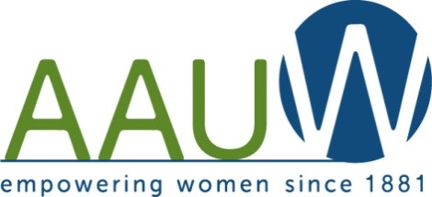

December 2018 Newsletter
Mankato Branch

December Board Meeting: No Board Meeting

December Branch Meeting:
The meeting will be held on Tuesday, December 11th at 5:30 pm.
It will be at Laurel’s Edge Community Room on Stadium Road.
This will be our Holiday Party. Fun Fun Fun.
Holiday Bingo, Annual Cookie Swap and Good Warm Food and Treats.
Bring 3 dozen (NO CHOCOLATE) cookies and an Empty Container.
The Bingo Game will be a fundraiser. So please bring cash to play.

Yankee Candle Order:
Thank you for all the orders that were placed. It went well. Details to follow at the meeting.
Josephine Bowden Scholarship Applications:
The 2018-2019 Josephine Bowden Scholarship applications have a deadline of December 3rd. We gave out and sent out many applications for this year. We will be notifying the winner in mid January.

Board and Branch Meeting Hostess List:
December : No Board Meeting
December Branch : Holiday Party Marla & Mary Mastin
January: No Meetings
February Board : Kim Bristol
February Branch : Kim Bristol & Gaylene Hirmer
March: No Board Meeting
March Branch: Sue Howard & Noreen Kruckeberg
April Board: Anita Dittrich
April Branch: Anita Dittrich & Joanne Boelke
May : No Board Meeting
May Branch : TBA

No Meetings in January

Tuesday, February 12, 5:30 at Laurel’s Edge. Community Room Barb Jackman, Memoirist on weddings and funerals

Tuesday, March 12, 5:30 at Laurel’s Edge. Community Room Women in the Media - Karen Wright, KMSU Radio and Erica Brooks, KEYC-TV

Tuesday, April 9, 5:30 at Laurel’s Edge. Community Room
Michelle Stuckenbroker, Sam’s Club Pharmacist

Tuesday, May 14, 5:30 location to be determined.
Scholarship recipient introduction and State Convention reports.

