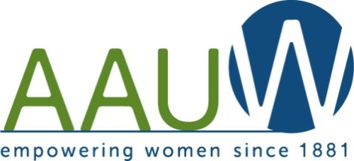

February/March 2019 Newsletter
Mankato Branch

HAPPY NEW YEAR!!!!!
January/February:
What a snowy beginning to 2019. Let’s hope it does not last a long time.
The Groundhog says, an early spring. Let’s hope that he is correct this year.
Sorry for cancelations and postponing meetings, but safety with weather comes first for our members.
February Branch Meeting:
Our speaker for February will be Barb Jackman. She is a Memoirist and will speak about weddings and funeral details.
Yankee Candle Order:
Thank you for all the orders that were placed. It went well. We had a smaller order this year, but it still was a fundraiser that is worth doing. We made a profit of $96.00.

Make Sure to Check Out Our New Website at: www.aauwmankato.org
Toys for Tots:
Thank you to all that supported our donation to the Toys for Tots 2018 campaign. Looking forward to supporting the new Team in Mankato this year.

Josephine Bowden Scholarship :
The 2018-2019 Josephine Bowden Scholarship has a winner. We will meet and give out the scholarship to Courtney Anderson at our April meeting.
Thank you to the committee for assisting this year with the applications.

AAUW State Convention:
The 2019 Minnesota State Convention will be held on April 26th and 27th in Grand Rapids. The Convention will be at the Timberlake Lodge & Event Center. Anyone interested in attending, please let Marla and Mary know.

Board/ Branch Meeting Hostess List:
February Branch : Kim Bristol & Gaylene Hirmer
March: No Board Meeting
March Branch: Sue Howard & Noreen Kruckeberg
April Board: Anita Dittrich
April Branch: Anita Dittrich & Joanne Boelke
May : No Board Meeting
May Branch : TBA

Calendar Recap:

Tuesday, March 12, 5:30 at Laurel’s Edge. Community Room Women in the Media - Karen Wright, KMSU Radio and Erica Brooks, KEYC-TV

Tuesday, April 9, 5:30 at Laurel’s Edge. Community Room
Michelle Stuckenbroker, Sam’s Club Pharmacist and Award Scholarship.

Tuesday, May 14, 5:30 location to be determined.
Scholarship recipient introduction and State Convention reports.

______________________________________________________________________________________________________

Mankato AAUW Spring Bakeless Bake Sale
Bring Good Luck to our Mankato Branch
Please assist in supporting yet again another great year.
We have all had a part in making our Branch hit great milestones.
Please make your check out to the Mankato AAUW for your delicious support for your part of the measuring cup. Please return this slip with your check to Marla or Mary by the March 12th Branch meeting. Thank you for your support.
Name: ______________________________

